**RFID SCANNER SERIAL COMMUNITION ARDUINO – VB.NET**

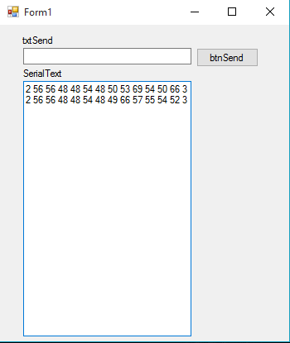

**VB.NET CODE**

Public Class Form1

Dim WithEvents SerialPort As New IO.Ports.SerialPort

Private Sub ConnectSerial()

Try

SerialPort.BaudRate = 9600

SerialPort.PortName = "COM3" 'notice how the ports are named? they HAVE to have COM in front of the number

SerialPort.Open()

Catch

SerialPort.Close()

End Try

End Sub

Private Sub Form1_Load(ByVal sender As System.Object, ByVal e As System.EventArgs) Handles MyBase.Load

ConnectSerial()

End Sub

Private Sub btnSend_Click(sender As Object, e As EventArgs) Handles btnSend.Click

If SerialPort.IsOpen Then

SerialPort.Write(txtSend.Text)

Else

ConnectSerial()

SerialPort.Write(txtSend.Text)

End If

End Sub

Delegate Sub myMethodDelegate(ByVal [text] As String)

Dim myD1 As New myMethodDelegate(AddressOf myShowStringMethod)

Sub myShowStringMethod(ByVal myString As String)

'display text to our textbox called SerialText

SerialText.AppendText(myString)

End Sub

Private Sub SerialPort_DataReceived(ByVal sender As Object, ByVal e As System.IO.Ports.SerialDataReceivedEventArgs) Handles SerialPort.DataReceived

Dim str As String = SerialPort.ReadExisting()

Invoke(myD1, str)

End Sub

End Class

**ARDUINO CODE**

#include <SoftwareSerial.h>

SoftwareSerial RFID(2, 3); // RX and TX

int i;

void setup()

{

RFID.begin(9600); // start serial to RFID reader

Serial.begin(9600); // start serial to PC

}

void loop()

{

if (RFID.available() > 0)

{

i = RFID.read();

Serial.print(i, DEC);

Serial.print(" ");

}

}